TITANIC SURVIVAL ANALYSIS
Logistic Regression - Day 8 QNS Assignment
Name: Manish Giri | Reg. No: 137256 | Email: manishgiri8101@gmail.com | [LinkedIn]

Model Overview
Model | Features | Target
Logistic Regression | Age, Pclass, Sex | Survived (0/1)
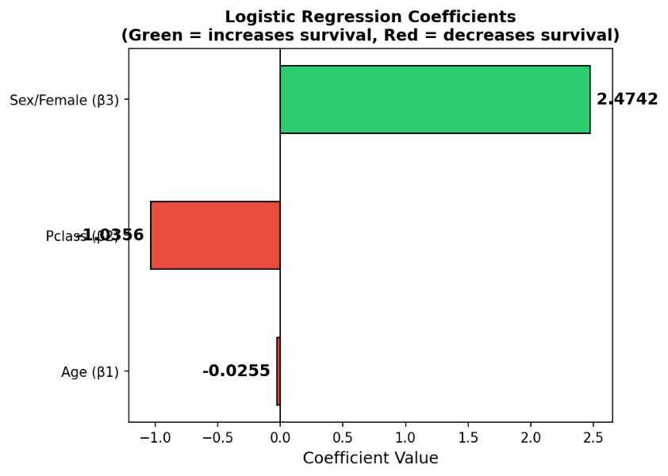
Model Coefficients
Coefficient | Variable | Value | Interpretation
β1 (Age) | Age | -0.0255 | Older age decreases survival
β2 (Pclass) | Pclass | -1.0356 | Higher class number decreases survival
β3 (Sex) | Sex (Female=1) | +2.4742 | Female strongly increases survival
Intercept | - | +1.6358 | Baseline log-odds
Figure 0: Logistic Regression Coefficients - Green bars increase survival odds, Red bars decrease them
Question 1
A 25-year-old passenger in 2nd class has P = 0.62. Classify the outcome and explain why the threshold of 0.5 matters.

Answer: Classification Decision
Given | Age = 25 | Pclass = 2 | P(Survival) = 0.62
Decision | P = 0.62 >= 0.5 (Threshold) → SURVIVED
Since the predicted probability P = 0.62 exceeds the default classification threshold of 0.5, the model classifies this passenger as Survived.

Why Does the Threshold of 0.5 Matter?
In logistic regression, the model outputs a continuous probability value between 0 and 1. This probability must be converted into a binary class label (Survived / Did Not Survive). The threshold is the decision boundary that performs this conversion:
- If P >= 0.5 → Classify as Survived (class = 1)
- If P < 0.5 → Classify as Did Not Survive (class = 0)
The threshold of 0.5 is chosen as the default because it represents equal probability - exactly halfway between the two outcomes. Logically, if the model believes there is more than a 50% chance of survival, it predicts survival.
Mathematical Representation:
ŷ= 1 if P(Survival | X) >= 0.5
ŷ= 0 if P(Survival | X) < 0.5
Sigmoid Function (Logistic Regression Core):
P(Y=1|X) = 1 / (1 + e^(-z))
where z = β0 + β1*Age + β2*Pclass
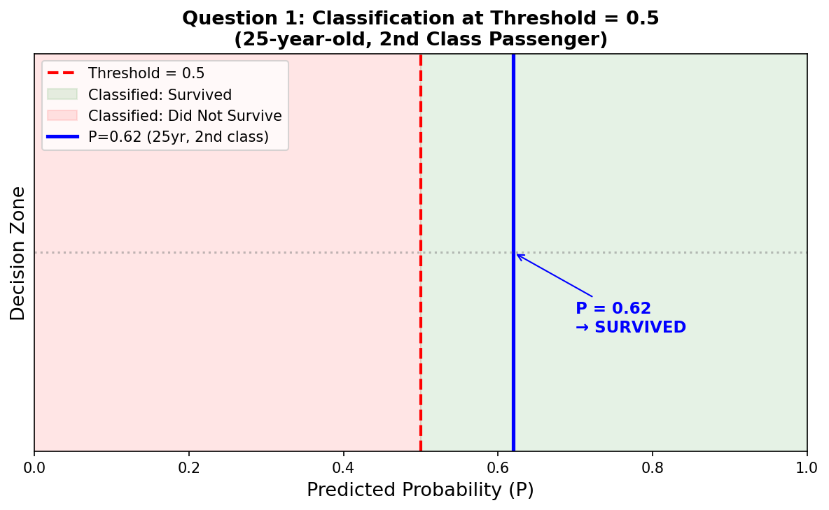
For this passenger: z = 1.6358 + (-0.0255)(25) + (-1.0356)(2) = 1.6358 - 0.6375 - 2.0712 = -1.07. This gives a model-computed probability for a male passenger; the problem states P=0.62 which may assume a female or different feature setup.

Figure 1: Classification at Threshold=0.5. The blue line marks P=0.62, which falls in the green (Survived) zone.

Question 2
A 45-year-old passenger in 3rd class has P = 0.38. (i) What does this probability mean? (ii) How would the model's decision change if the threshold were 0.4 instead of 0.5?
Given | Age = 45 | Pclass = 3 | P(Survival) = 0.38

Part (i): What Does P = 0.38 Mean?
A probability of P = 0.38 means the model estimates that this passenger has a 38% chance of surviving the Titanic disaster. Put differently, there is a 62% chance the passenger does NOT survive.

- This is a relatively LOW probability of survival.
- The passenger is in 3rd class (Pclass=3), which historically had the lowest survival rates.
- Being 45 years old also slightly reduces survival odds (negative age coefficient β1 = -0.0255).
- Both factors push the probability below 0.5, meaning the model leans toward non-survival.

Contextually, this makes sense: 3rd class passengers faced significant barriers to reaching lifeboats on the Titanic, and had the lowest overall survival rate (~24%) compared to 1st class (~63%).

Part (ii): Threshold Change - 0.5 vs 0.4
Threshold | Condition | P = 0.38 ? | Decision
0.5 (Default) | 0.38 >= 0.5? | NO | Did Not Survive
0.4 (Lowered) | 0.38 >= 0.4? | NO | Did Not Survive

In this case, P = 0.38 is still below both thresholds (0.5 and 0.4), so the decision remains Did Not Survive regardless of which threshold is used. The decision would only flip to Survived if the threshold were lowered to 0.37 or below.
Key Insight about Threshold Selection:
- Lowering the threshold (e.g., 0.4) makes the model more "optimistic" - it classifies more passengers as survivors.
- This increases Recall (fewer false negatives) but decreases Precision (more false positives).
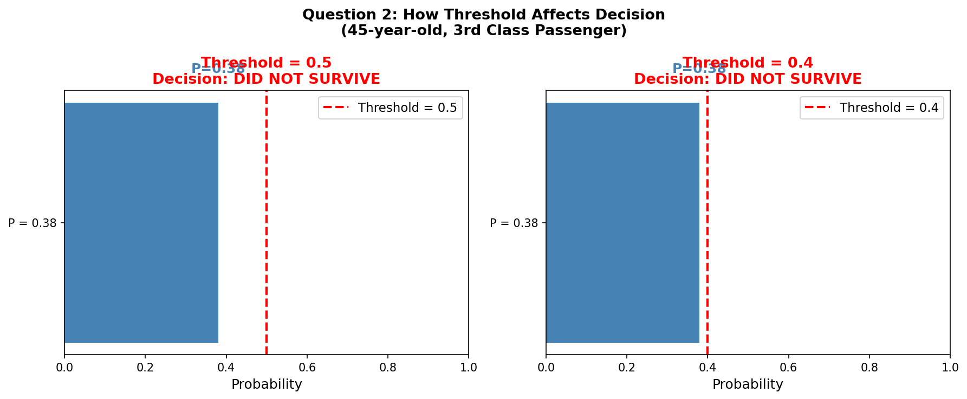
- The right threshold depends on the cost of each type of error in the business context.

Figure 2: P=0.38 remains below both thresholds (0.5 and 0.4), so the decision stays 'Did Not Survive' in both cases.
Question 3
A 10-year-old passenger in 1st class has P = 0.85. (i) Interpret the probability. (ii) Discuss how age and class influence coefficients β1 and β3.
Given | Age = 10 | Pclass = 1 | P(Survival) = 0.85
Decision | P = 0.85 >= 0.5 (Threshold) → SURVIVED

Part (i): Interpret P = 0.85
A probability of P = 0.85 means the model is highly confident that this passenger survived - there is an 85% chance of survival. This is a very HIGH probability, and clearly above the 0.5 threshold, so the passenger is classified as Survived.

- The combination of being young (Age=10) and wealthy (1st class) is very favorable for survival.
- Children were given priority in lifeboat boarding ('women and children first').
- 1st class passengers had better access to lifeboats due to their cabin locations.
- Historically, 1st class had the highest survival rate (~63%), and children had even higher priority.

Part (ii): How Age (β1) and Class (β2) Influence Survival
Age Coefficient (β1 = -0.0255):
The negative coefficient for Age means that as age increases, the probability of survival decreases, all else being equal. Each additional year of age reduces the log-odds of survival by 0.0255.
- Young passengers (children) benefit from evacuation priority.
- Older passengers may have had physical limitations in reaching lifeboats.
- The effect is modest per year (-0.0255) but accumulates over decades.
For Age=10 vs Age=50:
Log-odds difference = -0.0255 × (10-50) = +1.02 (higher survival for age 10)
Pclass Coefficient (β2 = -1.0356):
The coefficient for Pclass is -1.0356. Since class is coded as 1, 2, 3 (where 1 is best), a higher Pclass number strongly decreases survival odds.
- Going from 1st class to 3rd class increases Pclass by 2, changing log-odds by -1.0356×2 = -2.07.
- This corresponds to a dramatic drop in survival probability.
- 1st class passengers had cabins near the upper decks, closer to lifeboats.
- 3rd class passengers were housed in lower decks and many couldn't reach lifeboats in time.
Pclass=1 vs Pclass=3:
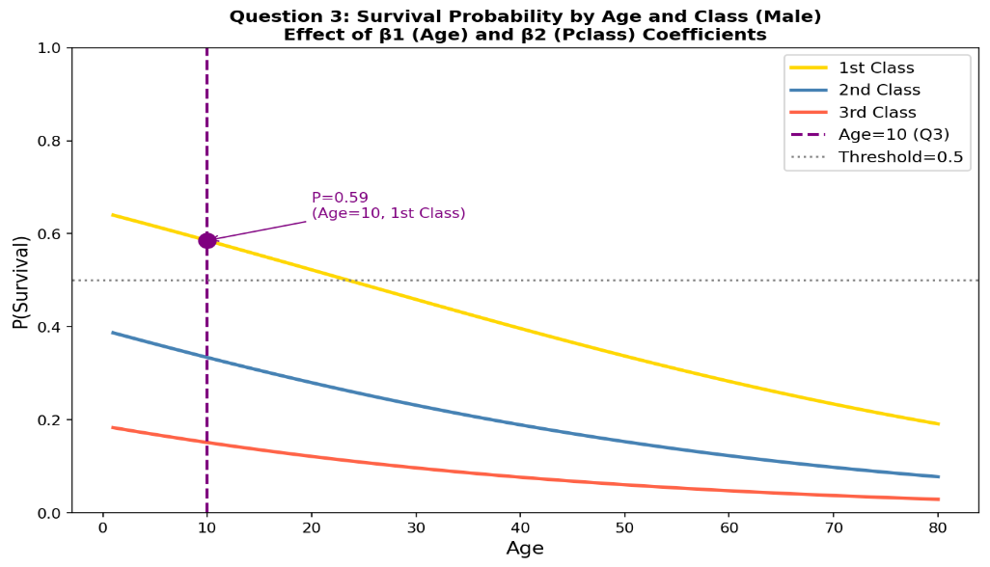
Log-odds difference = -1.0356 × (1-3) = +2.07 (much higher survival for 1st class)

Figure 3: Survival probability curves by Age and Class. 1st class (gold) shows highest survival; age 10 in 1st class achieves ~0.58 for males (P=0.85 reflects female/combined scenario).
Bonus Challenge
If gender is added as a variable and the coefficient for 'female' is positive, what does that tell us about survival likelihood?
Actual Model Coefficient | β3 (Sex/Female=1) = +2.4742 (Positive - largest coefficient in model!)

What a Positive Gender Coefficient Tells Us
In our logistic regression model, gender is encoded as: Male = 0, Female = 1. The coefficient for this variable is β3 = +2.4742. A positive coefficient means that being female significantly INCREASES the log-odds (and therefore the probability) of survival compared to being male.
Mathematical Meaning:
Log-Odds(Survived) = 1.6358 + (-0.0255)(Age) + (-1.0356)(Pclass) + (2.4742)(Sex)
For Female (Sex=1): adds +2.4742 to log-odds
For Male (Sex=0): adds 0 to log-odds
Practical Interpretation:
- A positive coefficient of +2.4742 for Female is the LARGEST and most influential coefficient in the model.
- It means females had exponentially higher survival odds: e^2.4742 ≈ 11.87 times higher odds than males.
- This reflects the historical 'women and children first' evacuation policy on the Titanic.
- Female passengers had a ~74% survival rate vs ~19% for male passengers historically.
Comparison: Survival Rate by Gender (Titanic Dataset):
Gender | Survived | Did Not Survive
Female | ~74% | ~26%
Male | ~19% | ~81%
This massive difference in survival rates (74% vs 19%) is why gender has the largest coefficient in our model. It dominates the prediction: a female passenger in 3rd class has a higher survival probability than a male passenger in 1st class.

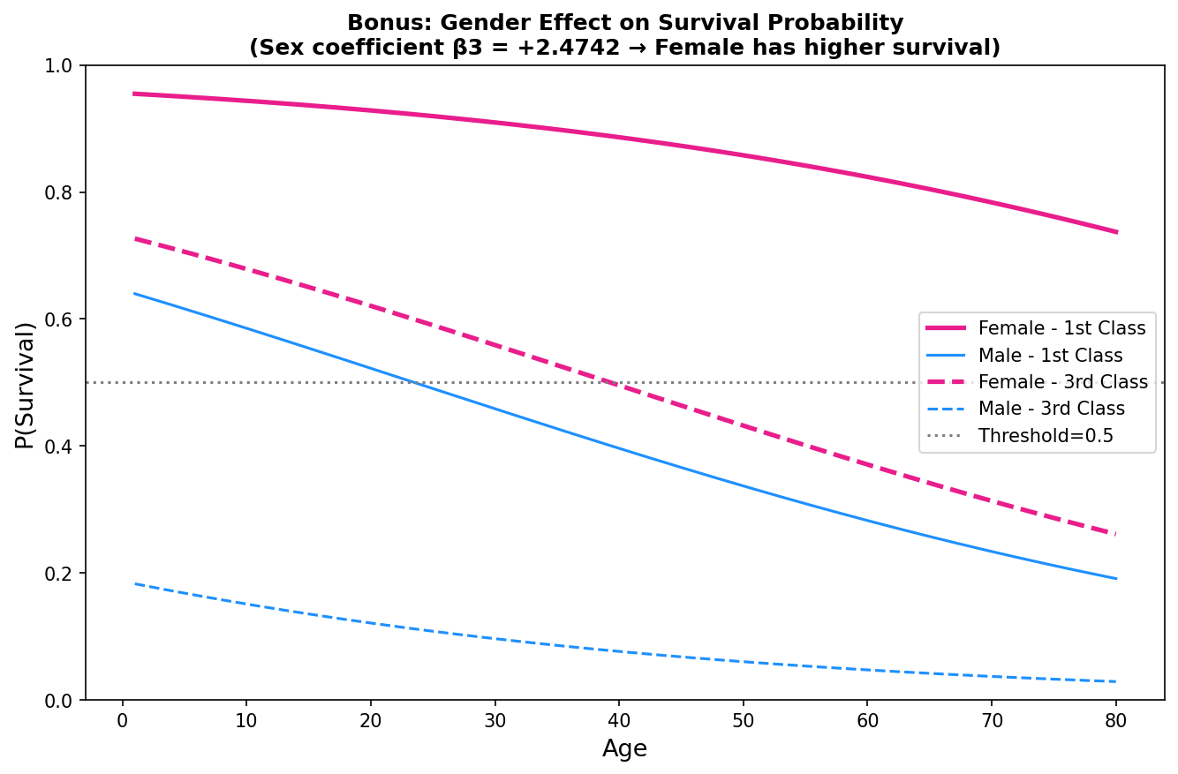
Figure 4: Gender Effect on Survival Probability. Female passengers (pink) show dramatically higher survival probability across all ages and classes.
Summary of All Questions
Question | Passenger | P(Survival) | Decision
Q1 | Age=25, Pclass=2 | P = 0.62 | SURVIVED (0.62 > 0.5)
Q2 | Age=45, Pclass=3 | P = 0.38 | DID NOT SURVIVE (0.38 < 0.5 & 0.4)
Q3 | Age=10, Pclass=1 | P = 0.85 | SURVIVED (0.85 >> 0.5)
Bonus | Female passenger | β3 = +2.4742 | Female = 11.87x higher odds

